**Abstract**

We propose a specialized DCNN to distinguish five phases in a gait cycle, based on IMU data and classified with foot switch information.

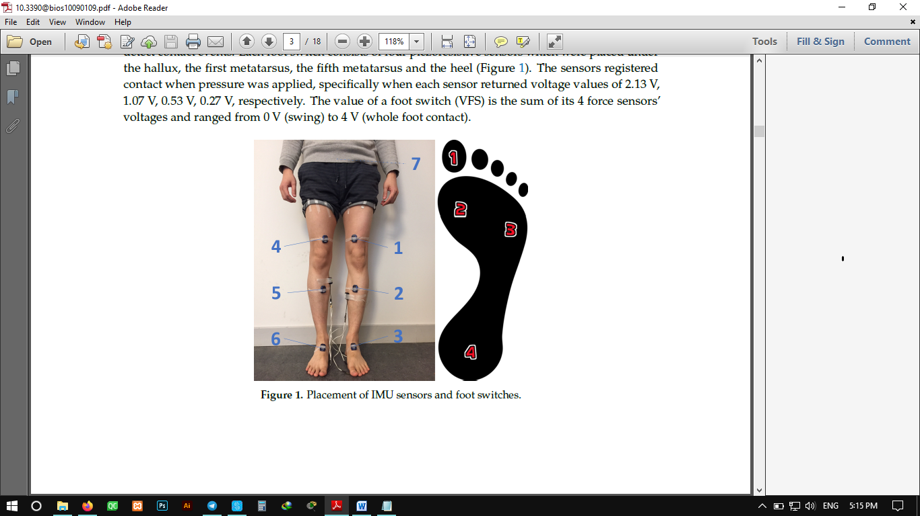

12 able-bodied subjects (6 males and 6 females) between 25 and 30 years.

Subjects were equipped with seven IMUs ,attached with tape to the thighs, shanks, feet and pelvis, as well as with foot switches.

The sensors registered contact when pressure was applied.

The value of a foot switch (VFS) is the sum of its 4 force sensors’ voltages and ranged from 0 V (swing) to 4 V (whole foot contact).

loading response (LR),

midstance (MS),

terminal stance (TS),

pre-swing (PSw)

and swing (SW).

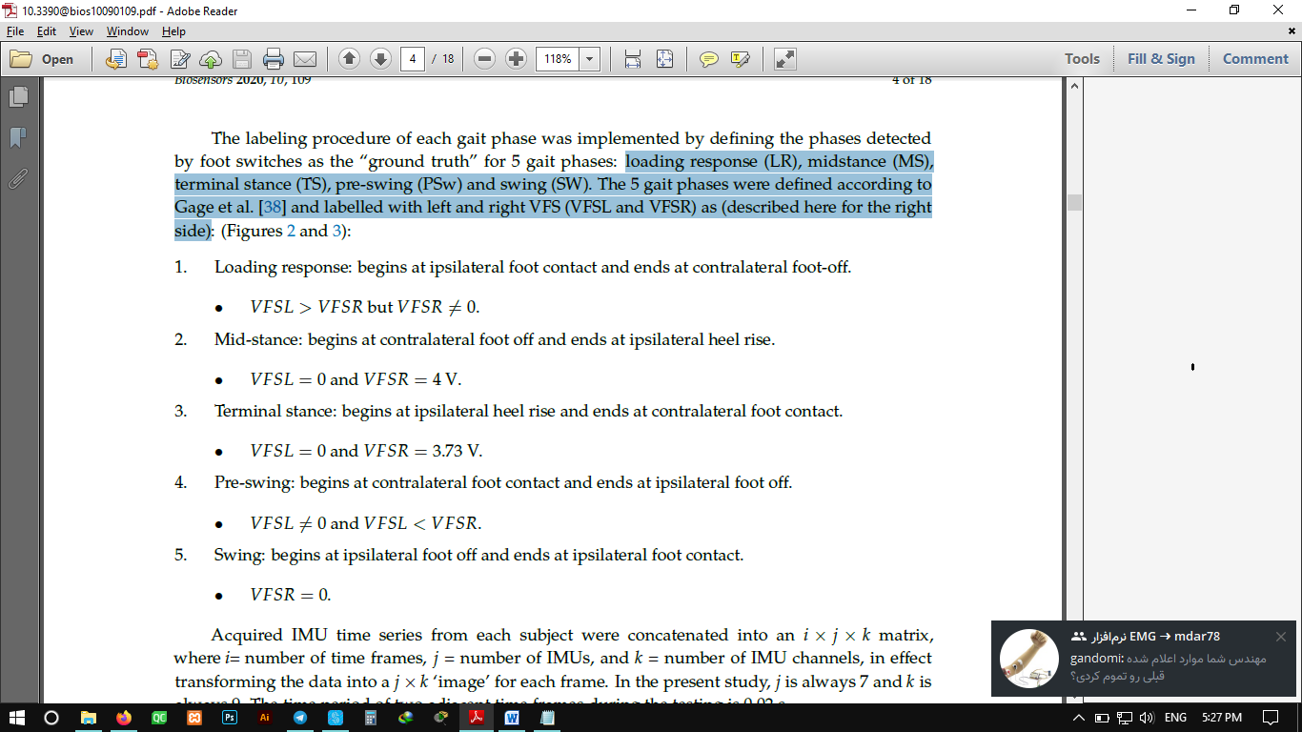

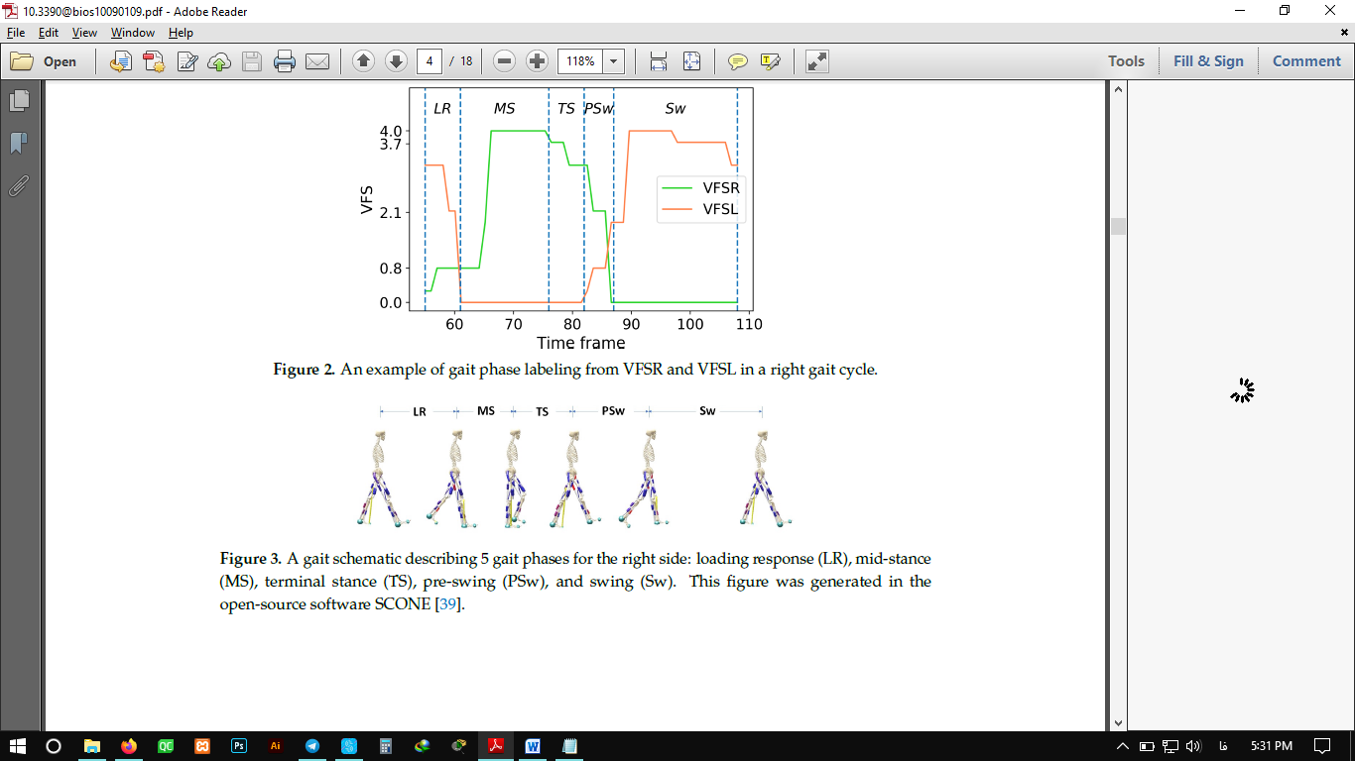

DCNNs have been largely applied in the task of feature extraction, image recognition and time series data classification due to the advance of computational power and large amounts of labelled data.

3 - DCNN model

In a DCNN, the input, commonly a three-dimensional tensor, goes through a sequence of processing, usually called a layer. This can be a convolution layer, a pooling layer, a normalization layer, a fully connected layer, a loss layer.

Ideally the DCNN can extract prominent feature from the IMU ‘image’ by applying filters in the convolution layer.

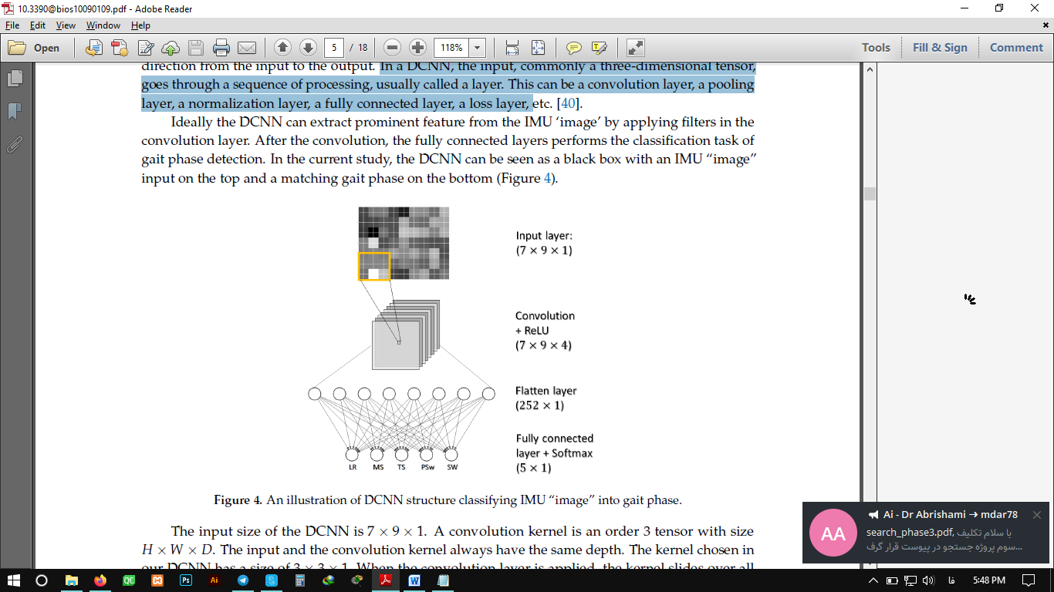

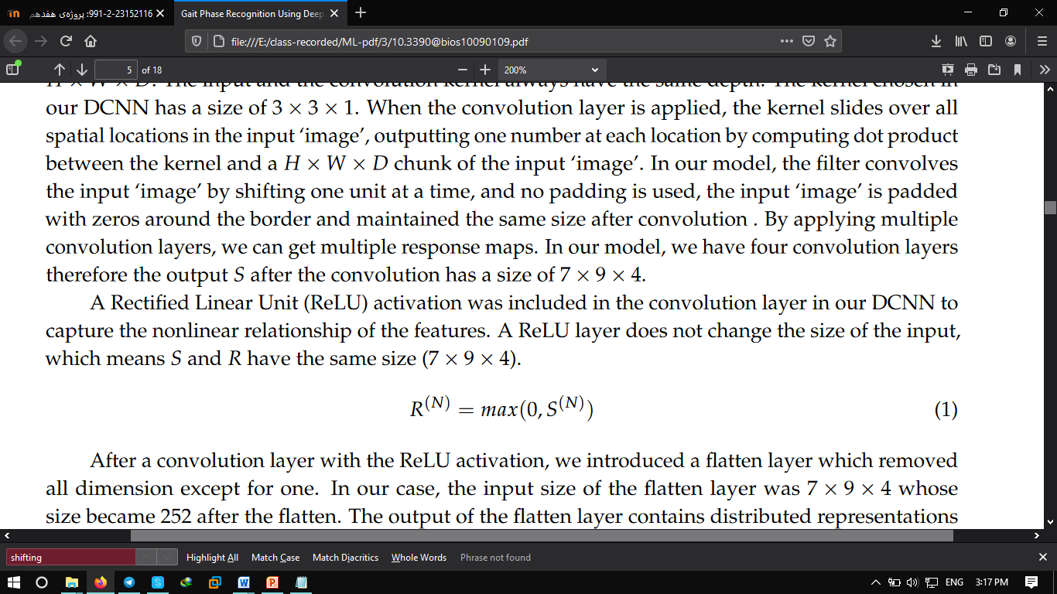

The output of the ﬂatten layer contains distributed representations for the input image, and all these features in the current layer can be used to build features with stronger capabilities in the next layers.

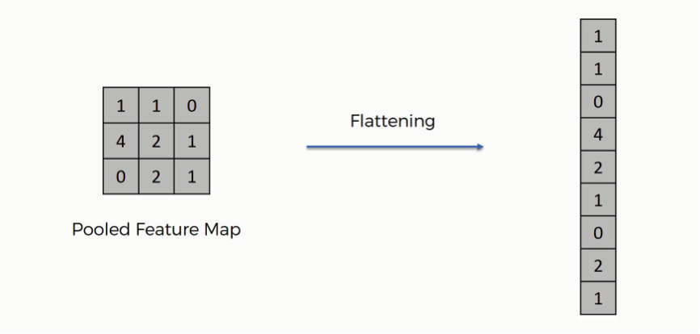

we used a Soft matrix activation (Equation (2)) which maps non-normalized output to the probability distribution over predicted classes.

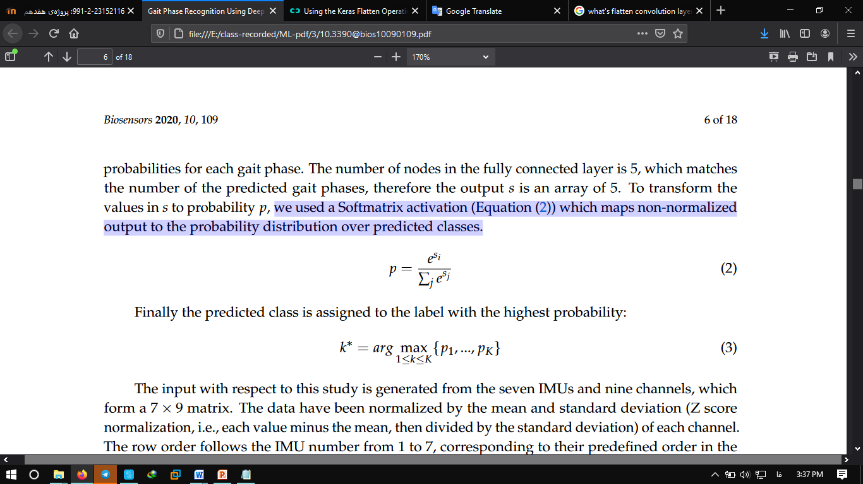

DCNN Performance Evaluation:

Implements:

trained the ﬁrst 70% - tested on the last 30% data for each speed - walking speed affects the recognition accuracy of the gait phases

randomly trained on 70% data - tested on the remaining 30% data for each subject - evaluate the performance of the proposed DCNN

pooled data of all ﬁve speeds and all subjects but one - test data were from one “unseen” subject - was designed to investigate the reliability of a general model.

**Results:**

**I =** the computational time for training and testing was approximately 21 s and 0.12 s.  
**II =** 101 s and 0.34 s  
**III =** 300 s and 0.54 s

* Intra-Subject I Implementation

1. The overall accuracy on all gait phases isapproximately 96.8%.

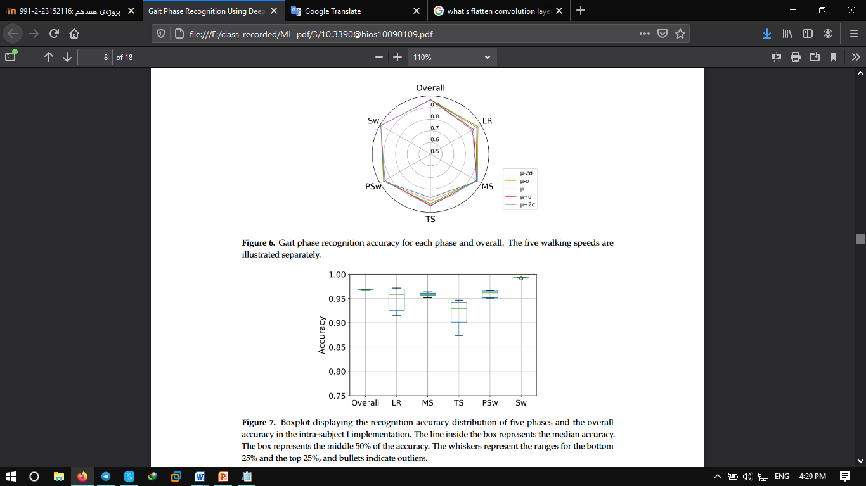

1. Overall accuracy 97.1%. Recognition variability was highest in LR, TS and PSw

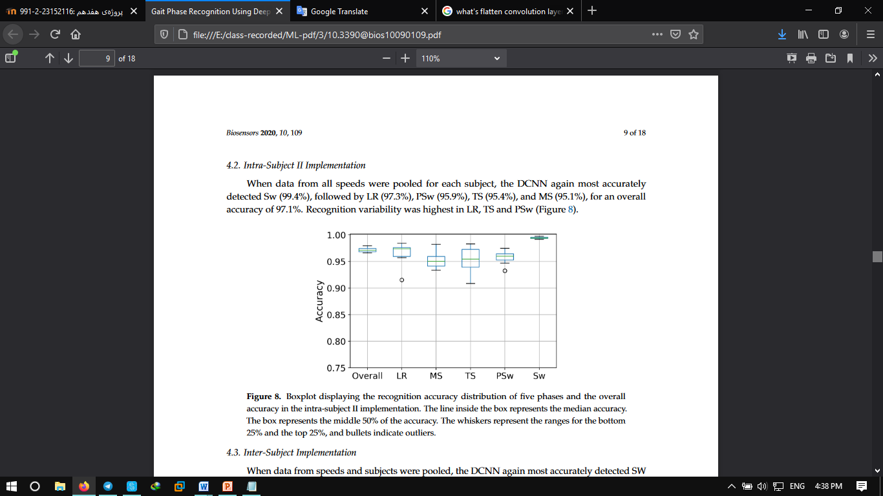

1. overall accuracy 95.6%

